R&I Best Practices for Google Cloud
21st August 2024

STAKEHOLDERS

Internal
Riad Bacchus and Jeremiah Chuang have the input on these

External
Cheryl Mackinnon sets priorities and can override anything in this document

OVERVIEW
Using Google Cloud for reporting and insights workflows and methods has some non-intuitive processes. These are detailed here
Deadlines
Microsoft will be totally gone in October. Some R&I team members will retain access to things such as Excel & Power BI.

PREREQUISITES

Power BI License & Permissions
- Developer can either have Power BI Premium per User (PPU) or Power BI Pro license
- The Developer needs access to workspaces for Dataflows, testing, and production environments
- Recommended, but Optional: The Developer may need ability to export files (.pbix and .xlsx)

Google Account
IT takes care of this Just email itservicedesk@saddleback.com

Google Drive access permissions
IT takes care of this. Just email itservicedesk@saddleback.com

Cutover Procedures

File storage

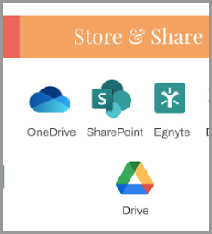
Before: Egnyte/Sharepoint/local computer
After: Shared Google Drive File repositories
For .pbix reports: Report Version Files
For Data sources: Data Sources for Reports

Converting Excel documents to Google Sheets
Power BI to Google Sheets Guide
Comments on Power Query formatting
- Nulls turn into blanks
- Extra rows in the Google Sheet become rows in Power Query
  - Filter these out in Power Query

New Methods

Chat and Collaboration
- Google doesn't have the ability to name a group chat.
- However, we could convert this group chat into a Space, which would facilitate chat, threads, and file sharing. Only if we need it

File Sharing
Google Sheets require certain permissions for Share > Link > Manage Access. Depending on if any users are external to the organization, they may need the Google Sheet to be open to “Anyone with the link”
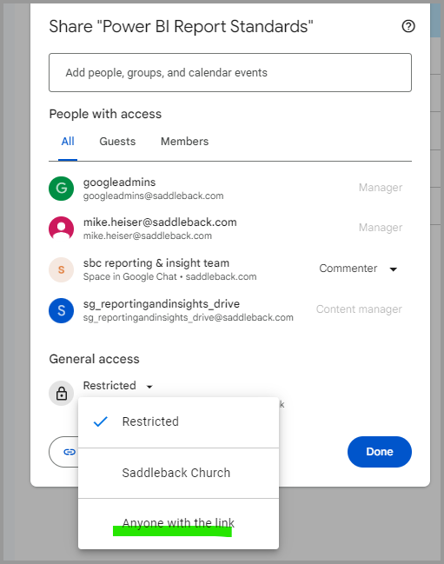

Desktop to Drive Integration
Google Drive can sync folders on your computer with those in your Drive so you don’t have to manage multiple copies of files.
- Download & Sign In when prompted
- Access or Add folders/files to your new Google Drive (G:) > My Drive
- Click Gear > Preferences > Syncing options > select “Mirror Files”
  - Reports are large files, which means Streaming (default) has longer sync times
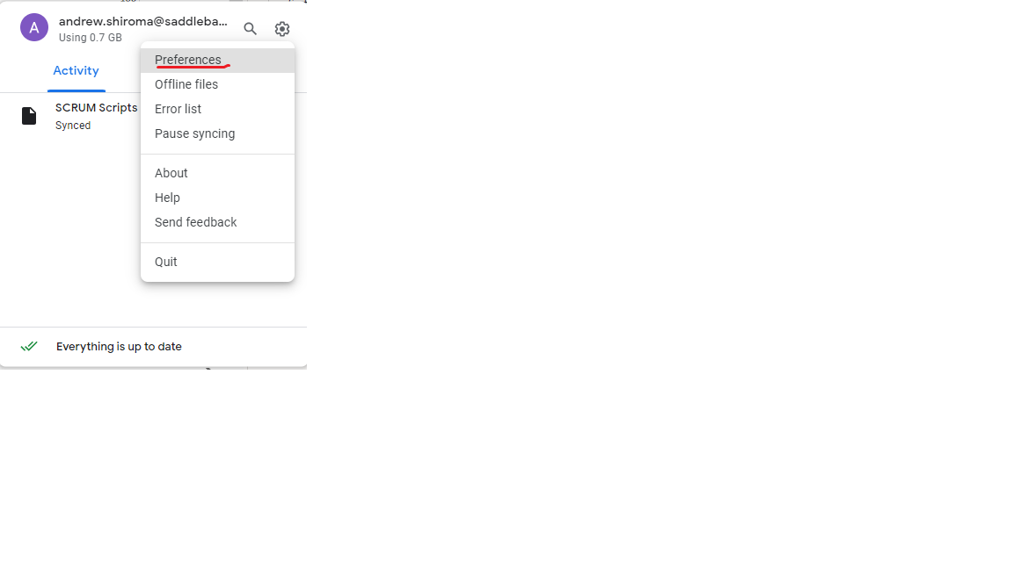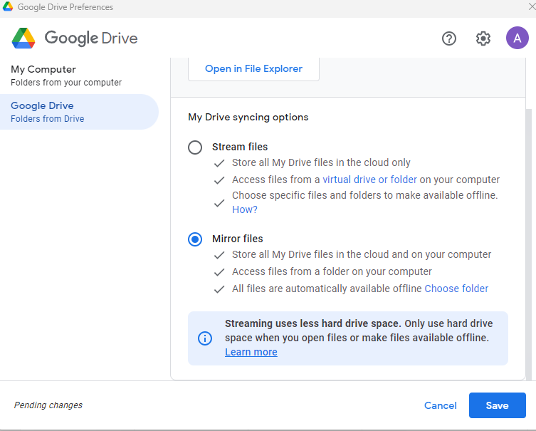

Report Development and revisions
- Check that for each report, Google Drive has a file folder structure for these 4 folders
  - 01_Report Repository
  - 02_Report Objects
  - 88_Testing
  - 99_Production
- Download .pbix from Google Drive
- Follow Version Control process and update hidden pages within .pbix. PBI Version Control Process v2.pdf
- Save versions to Google Drive as .pbit for backup into 01_Report Repository (each report should have this folder)
QA in (DEV) workspaces
Same as before
Visualization
Same as before. See this folder for standard guidelines: Power BI Report Standards

Deploying Reports

Power BI Service (Browser based)
If a semantic model is using Google Sheets, then the credentials have to be input into the settings.

Exports
Currently the Power BI button for Export data produces a file in Excel. The best user experience would convert these extracts into Google Sheets seamlessly.
Power BI to Google Sheets Guide

Potential Ideas to try
Google sheets can make templates. We could use this to standardize visuals on extracts

Work in progress page
Stuff you can do now BEFORE go-live:
- Use chat.google.com, not gmail.com
- Spaces:
  - External member access: Set only at creation
    - Enables "Copy link to this space" button
  - Threads: a method to focus conversations & Reduce notifications for other team members.
  - Configurable notifications
- MEET:
  - Intuitive interface
  - Auto-frame camera setting
  - Companion Mode: For conference rooms, no audio
  - Calendar integration:
    - Meet options in G-Cal events
    - Attachments visible in Meet
  - R&I team will Use Contributors, not Viewers role
AFTER go-live:
- Best practice: continue to use chat.google.com, not gmail.com
- Strong recommendation: Switch to Chrome browser
  - Import bookmarks

